User Requirement Specification (URS)
Vending Machine Control System (VMCS) Computer Simulation
Document Reference: |  | ISS/VMCS/TR.1/V2.0
Project: |  | VMS
Document Title: |  | Volunteer Management System User Requirement Specification (URS)
Version: |  | 1.0
Author: |  | Team 08
 | © 2001  The information contained in this document is the property of ISS. The contents must not be copied in whole or in part for purposes other than which it has been supplied without the consent of ISS, or, if it has been furnished under contract to another party, as expressly authorised under that contract, then ISS shall not be liable for any errors or omissions. | 
Institute of Systems Science, 25 Heng Mui Keng Terrace,
Singapore 119615

Version History Record
Version | Review & Approval Form Number | Date | Brief description of amendments and affected pages, paragraph
1.0 | ISS/VMS | 19/03/11 | First Issue
2.0 | ISS/VMS | 21/03/11 | Second Issue

Table of Contents
1 INTRODUCTION 4
1.1 Background 4
1.2 Objectives 4
1.3 Organization 4
1.4 Scope 4
1.5 Definition of Terms 4
2 OVERVIEW OF REQUIREMENTS 5
2.1 Introduction 5
2.2 System Perspective 5
2.3 System Functions 5
2.4 User Characteristics 6
2.5 General Constraints 6
3 FUNCTIONAL REQUIREMENTS 7
3.1 Processing Requirements 7

INTRODUCTION

Background
The consulted organization is poverty elimination NGO. It has grown tremendously over the years and is attracting more and more volunteers both domestically and internationally. As it grows, there is an increasing need to coordinate and manage its volunteers, especially international volunteers as they require more administrative and logistic efforts. The current ways of manually handling documents and volunteers requires a lot of works and limiting the organization efficiency.
From the situational analysis and problems identified, our team proposed an integrated system with the aim of addressing the problems of volunteer communication, documentation, recruitment and retention.

Objectives
The objectives of this document are to:
- define the functional requirements for the VMS
- define the non-functional (i.e. operational and quality) requirements that would be necessary to support the functional requirements
- define the operational environment of the system.

Organization
Section 1 gives an introduction to this document.
Section 2 presents an overview of requirements for the system.
Section 3 presents the functional requirements and
Section 4 describes the operational and quality requirements.

Scope
This user requirement specification is solely concerned with the development of the VMS.

Definition of Terms
The following terms have special meanings within this document:
- The word shall imply a mandatory requirement.
- The word should imply a desirable requirement.
- The word will imply a mandatory requirement outside the scope of this document.
- The word may imply a desirable requirement outside the scope of this document.

OVERVIEW OF REQUIREMENTS

Introduction
The Volunteer Management System operates and maintains a large number of volunteer information and project information. Previously, this information is controlled manually. With the fast organization growth, it is very difficult to maintain and manipulate all the information manually and the organization has been decided to move to a computerised control system that will be access through intranet and internet.

System Perspective
The VMS allows the volunteers to register their own account, let them post the feedback to the project based on their experience and idea and sharing their inspiring stories and experience, etc...By providing such features will support the fast growth of organization with different insight and knowledge from different people. It also allows the internal staff to maintain the project related information such as project details, itinerary plan, project calendar, project member, etc... and reporting features which will describe the required summary and detail information.

System Functions
System functions to be implemented are:
No | Functions
Login
- Login
Volunteer Management
- Register Volunteer Account
- Update volunteer profile
- Forget Password
- Change Password
- Browse for Projects
- Raise Interest to Project
- Review Project Interest by volunteer and assign volunteer to Project
- Post Feedback to Project
- Post Experience or Inspiration stories
- Review and Approve Feedback
- Send Request for Certificate
- Manage Volunteer Account
Staff Management
- Register Staff Account
- Update Profile By Staff
- Forget Password
- Change Password
- Manage Staff Account
Project Management
- Propose Project
- Review and Approve Project Proposal
- Set-up Project Details
- Manage Projects
- Review Project Interest by volunteer and assign volunteer to Project
- Assign Roles to Project Member
- Set-up Project Calendar
Itinerary Management
- Prepare Itinerary Plan
- Submit Itinerary Plan
- Review and Approve Itinerary Plan
Reporting
- Volunteer Report
- Project Report
Certificate Management
- Generate Certificate
- Verify Certificate
- Print Certificate
System Control Panel
- Configure System Parameters

User Characteristics
For each project, the volunteer can play the following roles:
- acting as the project leader, who will manage a specific project (or)
- acting as the project member
The Internal Staff can play the following roles:
- acting as the Project Manager, who will manage one or more projects (or)
- acting as the system administrator, who will manage staff account (or)
- acting as the Administrator, who will manage volunteer account, generate report and certificate
- acting as the project Coordinator who will manage the project proposal and project itinerary plan approval
Each Volunteer and Internal Staff can play more than one role.

General Constraints
Dio: Existing hardware and software resources shall be used for this project. No additional resources shall be provided.
Development team can use any third party components to build.
Change to requirements will have to go through Change Management Process (Which will be defined in Quality Plan)

FUNCTIONAL REQUIREMENTS
This section describes the functional requirements of the VMS. The functional requirements are structured in terms of:
- Processing requirements – the main software functions to be provided to achieve the VMS
- User interface requirements – the required user interface to support the software functions.

Processing Requirements
The system is required to provide the software functions necessary for the application to manage volunteer and project information and for the volunteers and internal staff to perform their roles in using the system. Everyone can generally view the overview information of the organization before they decide to register as a volunteer. These functions are described in the following subsections.

Login

Login
- The system shall allow the volunteer to login to the system by entering the following information:
- Email Address
- Password
- The error message will appear if the provided email address or password is incorrect.
- The error message will also appear when the account is disabled by the system admin.

Volunteer Management
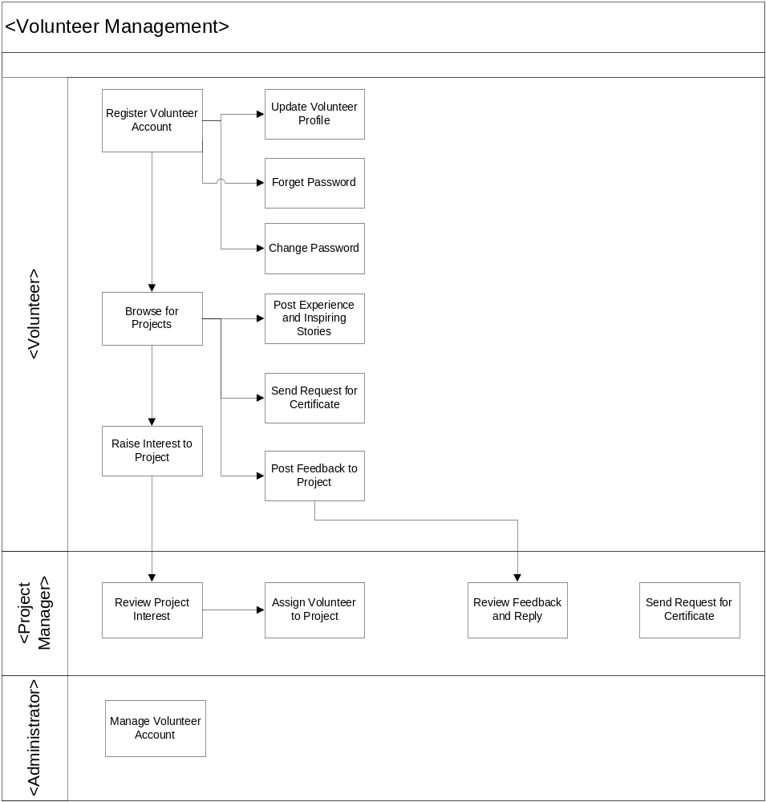
Volunteer Management Business Flow Overview

Register Volunteer Account
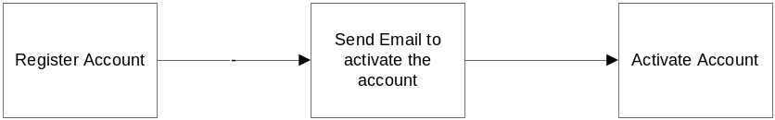

- Upon interesting to become a volunteer, the user can register the volunteer account in VMS. The system shall enable the important information of a new volunteer to be input to the system. These information shall be:
  - Email Address
  - Password
- The system shall create the account and send the notification email to the volunteer email’s address.
- The volunteer shall activate the account by clicking the link in the email sent from the VMS.
- After logging in to the VMS, the volunteer can proceed to update the profile.

Update Volunteer Profile
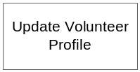
- The System shall allow the volunteer for the following volunteer details to be modified at any time after getting the account. The system shall enable details of the existing volunteer to be input/modify to the system. These details shall be:
  - Title( Mr. , Mrs. , Ms, Dr, Other)
  - First Name
  - Last Name
  - Address
  - Country
  - Email Address (Read Only Field)
  - Phone(Home)
  - Phone(Mobile)
  - Date of Birth
  - Hobbies/ Interests
  - Special Skills
  - Qualifications attained (Education)
  - Qualifications attained (Others)
  - Languages
  - Volunteer Interests (Admin, Befriending, Events (organizing), General Services, IT, Research, Marketing/Publicity, Skilled Services, Others)
  - Join Date(Read Only)

Forget Password
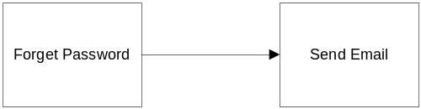
- The system shall allow generating the system generated password when the volunteer forget his or her password. It shall allow the user to input the
  - Email Address
- If the email address is valid , the successful password resetting will be notified to the volunteer via email. If the email address is not valid, an error message will appear.

Change Password
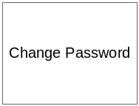
- The system shall allow the volunteer to change his/her preferred password at anytime.
  - Email Address
  - Old Password
  - New Password
  - Confirm New Password
- The error message appear if
  - Email address and old password is not valid
  - New password and confirm new password are not same

Browse for Project
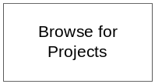
- After logging in to the system by the volunteer, the system shall display all the projects, either:
  - All the projects that the volunteer joined or that he is currently joining
  - All the ongoing projects which has enough team members and which is currently running
  - All the active projects which doesn’t have enough team members
    - The system shall display the project information and
    - The request status to join to the project
      - Requested (Request the project to join)
      - Cancelled (Request to join the project is cancelled by Volunteer)
      - Rejected (Request to join the project is rejected by PM)
      - Unsuccessful (There is more than one request to join the projects for the overlap period. When the volunteer is accepted by one project, the other project request for the overlap period will be reflected as Unsuccessful)
  - All the past project from 2 months ago or for a specified period

Raise Interest to Project
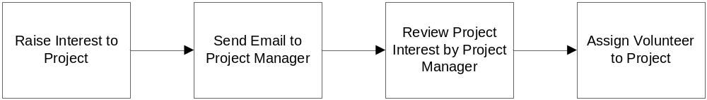

- For the active projects which are not started yet and which require more volunteers, the volunteer can raise the interest to the Project Manager. The volunteer can raise more than one project at a time.
- The system shall send the email to the relevant project manager when there is the interest request to the project.
- When the project request status is in Requested which means that the PM hasn’t decided to let the volunteer join the project, if the volunteer want to cancel his request, the system shall allow canceling it.
- The system shall send the email to the relevant project manager about his cancellation

Review Project Interest by volunteer and assign volunteer to Project
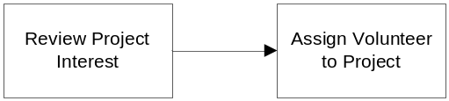
- The system shall allow the project manager to review the list of requested volunteer who want to join to a specific project. The system shall display the following information of the volunteer:
  - Title( Mr. , Mrs. , Ms, Dr, Other)
  - First Name
  - Last Name
  - Address
  - Country
  - Age
  - Hobbies/ Interests
  - Special Skills
  - Qualifications attained (Education)
  - Qualifications attained (Others)
  - Languages
  - Volunteer Interests (Admin, Befriending, Events (organizing), General Services, IT, Research, Marketing/Publicity, Skilled Services, Others)
  - Availability Status
  - Join Date (Read Only)
- If the volunteer submit two projects which falls the same or overlap duration and one project manager accepts him or her to join his project, the next project manager will see his availability status as Occupied and the PM shall not be able to assign him to his project.
- The project manager can accept/reject the volunteer request.
- When the project manager accept a volunteer request to join his project,
  - The system shall check if there is the other project request which fall the same period. If there is the request for the same project period, the project request status will be updated from Requested to Unsuccessful
  - The system will send the notification email to that volunteer about approval.
- When the project manager reject a volunteer request to join his project,
  - The project request status will be updated from Requested to Rejected
  - The system will send the notification email to that volunteer about rejection.

Post Feedback to Project

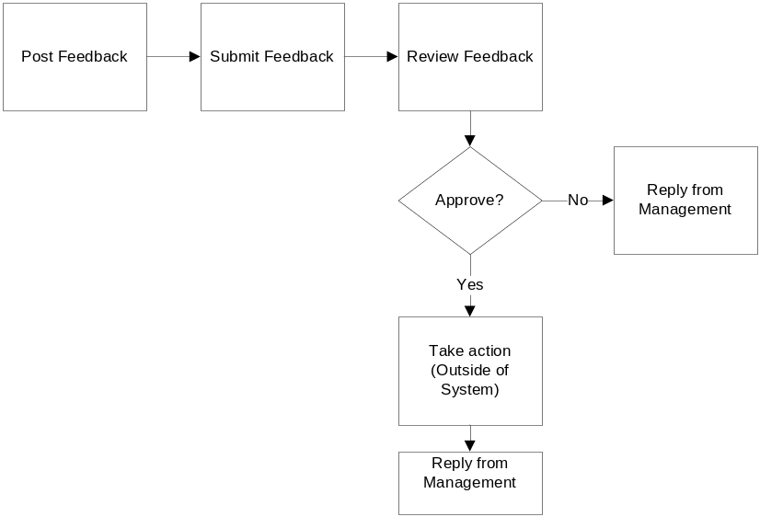
- The system shall allow the volunteer to post the feedback/suggestion to all kind of projects (Ongoing/Currently Joined/Past Projects). The system will provide the user to input the feedback/suggestion.
- The system shall allow that feedback to be modified or deleted by the feedback poster before the PM approval.
- The system shall not allow that feedback to be modified or deleted by the feedback poster after the PM approval.
- The system shall display all the feedbacks of a project to all volunteers but the system shall allow only the feedback owner to modify/delete it.

Post Experience and Inspiring Stories

- The system shall allow the volunteer to post their past experience or inspiring stories to the past projects. The system will provide the user to input the experience or inspiring stories.
- The system shall allow that experience or inspiring stories to be modified or deleted by the owner.

Review and Reply Feedback
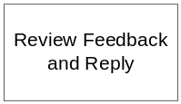
- The PM should check the posted feedback regularly for the projects he wants. The system shall allow the PM to view the feedback and approve/reject the feedback.(Note. To follow up the feedback/suggestion is the outside of the system.)

Send Request for Certificate
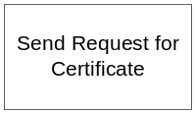
- The system shall allow sending the request for the Project Participation Certification to the system admin.
- The request can be done by two roles:
  - Project Manager (When the project is finished, project manager can send request the certificate for the whole team)
  - Volunteer ( When the volunteer want the certificate for a particular project he joined, volunteer can send the request)
- The system shall send the notification email to all the people with system admin role.

Manage Volunteer Account
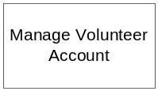
- The system shall allow the system admin for the viewing of volunteer details .These records will consist of:
- Title( Mr. , Mrs. , Ms, Dr, Other)
- First Name
- Last Name
- Address
- Country
- Email Address (Read Only Field)
- Phone(Home)
- Phone(Mobile)
- Date of Birth
- Hobbies/ Interests
- Special Skills
- Qualifications attained (Education)
- Qualifications attained (Others)
- Languages
- Volunteer Interests (Admin, Befriending, Events (organizing), General Services, IT, Research, Marketing/Publicity, Skilled Services, Others)
- Activity status (Active/Inactive)
- Join Date
- The system shall allow to activate/deactivate the volunteer account
- The system shall have the ability to retrieve the volunteer records, based on name, Email address or age group, but not to amend or delete them

Staff Management

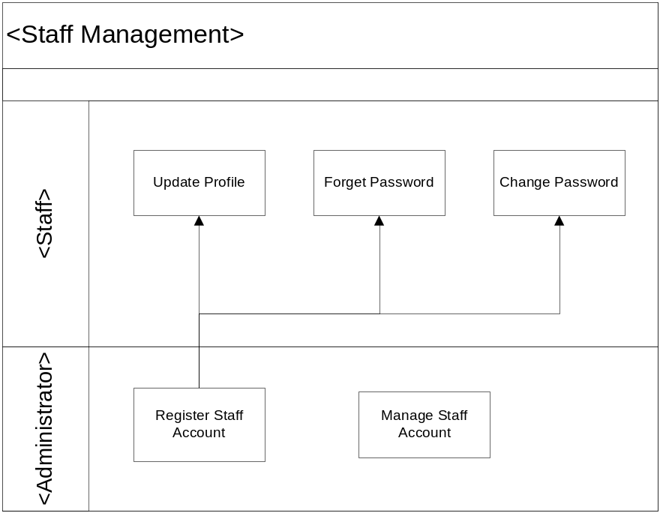

Staff Management Business Flow Overview

Register Staff Account

- When new staff joins organization, if he/she needs to access VMS, System Administrator shall register account for new staff. Upon creating a new staff, the system shall enable details of the new staff to be input to the system. These details shall be:
  - Title
  - First Name
  - Last Name
  - Email Address
  - Job Title
  - Role
- Then System shall send notification email to staff with user name and password to access VMS.

Update Profile by Staff
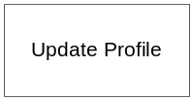
- The System shall the following staff account details to be modified at any time after getting the account. The system shall enable details of the existing staff to be input/modify to the system. These details shall be:
  - Title( Mr. , Mrs. , Ms, Dr, Other)
  - First Name
  - Last Name
  - Address
  - Country
  - Email Address (Read Only Field)
  - Phone(Home)
  - Phone(Mobile)
  - Date of Birth
  - Job Title
  - Role(Read Only Field)
  - Join Date

Forget Password
- The system shall to get the system generated password when the staff forgets his or her password. It shall allow the staff to input the
  - Email Address
- The successful password resetting will be notified to the staff via email if the email address is valid. If the email address is not valid, an error message will appear.

Change Password
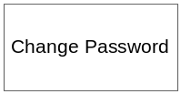
- The system shall allow the staff to change his/her preferred password at anytime.
  - Email Address
  - Old Password
  - New Password
  - Confirm New Password
- The error message appear if
  - Email address and old password is not valid
  - New password and confirm new password are not same

Manage Staff Account
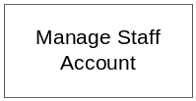
- The system shall allow the system admin for the maintenance of staff detailed .These records will consist of:
- Title( Mr. , Mrs. , Ms, Dr, Other)
- First Name
- Last Name
- Address
- Country
- Email Address (Read Only Field)
- Phone(Home)
- Phone(Mobile)
- Date of Birth
- Job Title
- Role
- Join Date
- Activity status (Active/Inactive)
- The system shall allow updating the staff records including assigning role. The system shall allow assigning more than one role to the staff.
- The system shall have the ability to retrieve the staff records, based on name, Email address but not to amend or delete them.
- The system shall allow activating or deactivating account when the staff leave the organization or rejoin the organization.

Project Management
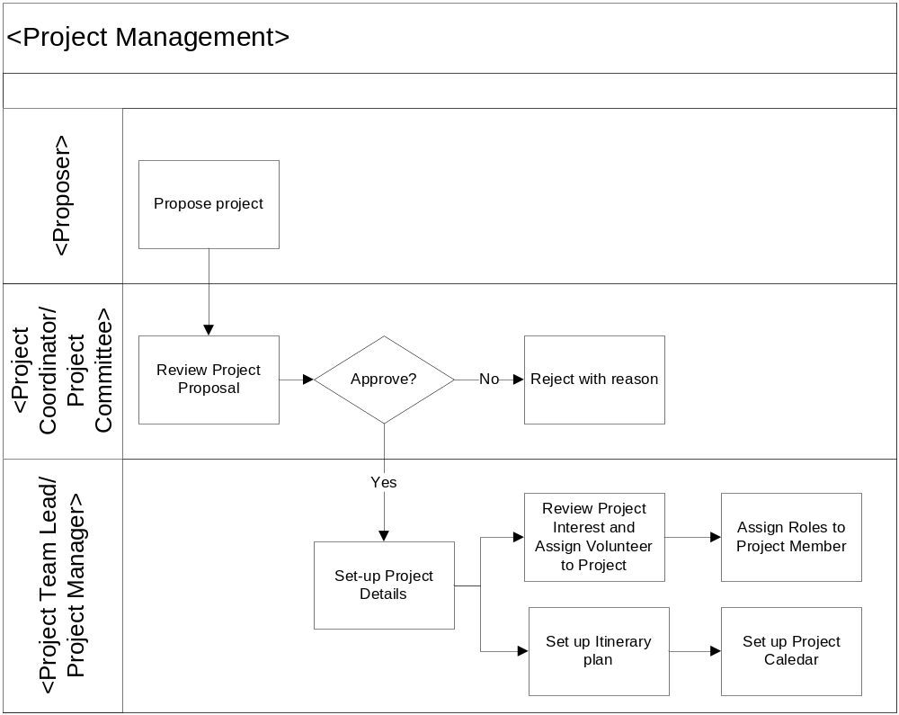
Project Management Business Flow Overview

Propose Project
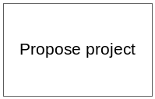
- The system shall allow the volunteer or internal staff to propose the project to the organization. The system shall accept the following details of the proposal.
  - Project Name
  - Project Description
  - Country
  - Location
  - Estimated Duration
  - Proposer
  - Created Date
- The system shall allow the volunteer or internal staff to view the proposal records and the status of the project proposal. The submitted proposal will have the following status:
  - Submitted (When the proposal is submitted to the Project Coordinator)
  - Rejected (When the proposal is rejected by the Project Coordinator)
  - Approved (When the proposal is approved by the Project Coordinator)
- The system shall also allow these details to be recalled and displayed.
- The system shall also allow these details to be modified by the owner before the approval.
- The system shall send the email to Project Coordinator about the submitted proposal. The Project Coordinator will review the Project Proposal with the Project Committee and this will be outside of the system.

Review and Approve the Project Proposal

- The system shall allow the project coordinator to review the Project Proposal information. In fact, the project coordinator will review the proposal with the relevant project committee members and which is outside of the system.
  - Project Name
  - Project Description
  - Country
  - Location
  - Estimated Duration
  - Proposer
  - Created Date
- The system shall allow project coordinator approving/rejecting the project proposal according to the decision of the project committee. The system will send the notification email to the proposer about the approval or rejection by the project coordinator.

Set up Project Details
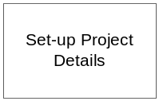
- Once the propose project is approved by the project coordinator, the project status will change to Approved and by that time, it is assumed that the project is set up.
- However, some projects are not proposed by volunteer or internal staff. Therefore, the relevant project manager can setup the project straight away without passing through the proposal project. The system shall enable details of the new project to be input to the system by the project manager. These details shall be:
  - Project Name
  - Project Description
  - Project Country
  - Project Location
  - Project Start Date
  - Project End Date
  - Project Status (Coming, On Going, Closed)
  - Project Manager

Manage Projects
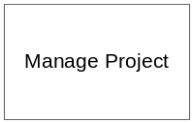
- The system shall allow all the staff with project manager role to view the project based on:
  - Project Name
  - Project Description
  - Country
  - Project Location
  - Start Date
  - Project Status(Coming, On Going, Closed)
  - Project Manager
  - Created Date
  - Project Progress Percentage

- The system shall allow the relevant project manager to modify his/her projects
  - Project Name
  - Project Description
  - Project Location
  - Country
  - Start Date
  - End Date
  - Project Status(Coming, On Going, Closed)
  - Created Date(Read Only)
  - Project Progress Percentage
- The system shall not allow the PM to delete the project.

Review Project Interest by Volunteer and Assign Volunteer to the Project
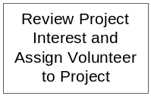
- Refer to...3.1.1.7

Assign Roles to Project Member

- The system shall allow the PM to assign roles to project members.
- The system shall also send the notification email to assigned volunteer.

Setup Project Calendar
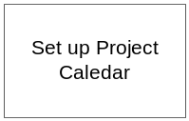
- After setting up the Itinerary Plan in next section (3.1.5), the PM can continue with setting up the project calendar. The system shall allow the creation and maintenance of details project calendar.
  - Itinerary Item Name/Task Name for each day of the calendar

Itinerary Management

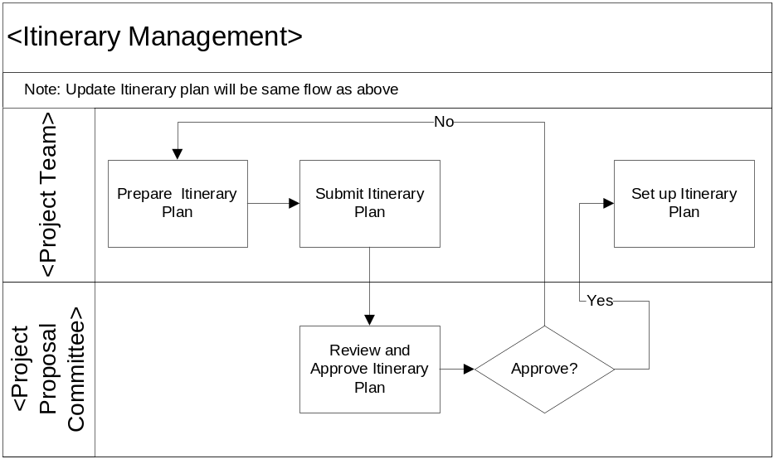
Itinerary Management Business Flow Overview

Prepare Itinerary Plan
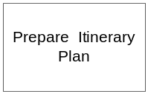

The project itinerary plan is made up with project itinerary items. The project itinerary item represents the phase/task within a project.

After setting up the project details, the system shall enable details of the project itinerary item to be put to the system by project manager. These details shall be:

Project ID

Task ID

Task Order No

Task Name

Task Description

Task Duration

Task Status

Drafting (Before submitting the Itinerary Plan)

Submitted (After submitting the Itinerary Plan)

Approved (After Approving the Itinerary Plan)

Rejected (After Rejecting the Itinerary Plan, Note: The system shall allow the PM to modify the Itinerary item with Rejected status and let them submit again after modification)

The system shall also allow these details of project itinerary item to be recalled or displayed.

The system shall also allow these details to be modified.

The system shall also allow project itinerary item records to be deleted if it is needed.

Submit Itinerary Plan
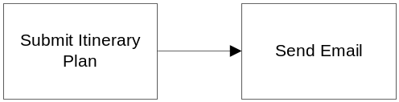

After preparing the itinerary Plan, the system shall allow to submit the itinerary plan to the project coordinator. The Itinerary Plan details will be:

Project ID

Approving Officer for Itinerary Plan / Project Coordinator. The system shall assist to show the list of the staffs with Project coordinator role in dropdown to choose.

Total Project Duration

Itinerary Plan Status

Drafting (Before submitting the Itinerary Plan)

Submitted (After submitting the Itinerary Plan)

Approved (After Approving the Itinerary Plan)

Rejected (After Rejecting the Itinerary Plan)

Once the Itinerary Plan is submitted to a project coordinator/ Approving officer, the system shall not allow modifying the project itinerary plan and itinerary items inside the plan.

The system shall send the notification email to the selected project coordinator for the submission of project itinerary plan

Review and Approve Itinerary Plan
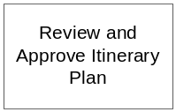

Upon receiving the notification email for project itinerary plan submission, the project coordinator will review it with the project committee and which is outside of the system.

The system shall allow the project coordinator to approve or to reject with the reason to the submitted project plan based on the project committee decision.

Upon approval or rejection by project coordination, the system shall send the notification email to the PM who submits the itinerary plan.

(Note: Once the project itinerary plan is approved in the system, it is assumed that the project itinerary plan is confirmed and setup in the system. PM cannot modify it anymore)

Reporting

The system shall allow generating Volunteer Report. The report shall present the following data:

Volunteer Name

The list of projects he/she has joined and is joining

Project Name

Project Start Date

Project End Date

Role in Project

The system shall allow generating Project Report. The system shall allow the Project Coordinator or PM to generate the project list by

Project’s start date which between user’s selected date

Project status

Project Manager

The report shall present the following data:
    - Project Name
    - Project Location
    - Country
    - Start Date
    - End Date
    - Project Status(Coming, On Going, Closed)
    - Created Date(Read Only)
    - Project Progress Percentage

Certificate Management

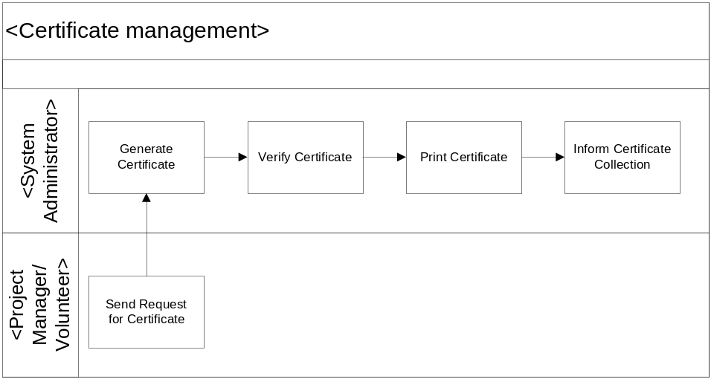
Certificate Management Business Flow Overview

Generate Certificate
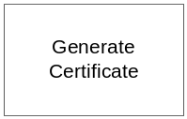

When the volunteer or project manager request for the certificate, all the staff with system administrator roles will receive the notification email. One of the system administrators will handle the request.

The system shall allow the system admin to generate the certificate based on:

Whole Project (for all project members)

A specific project member

Verify Certificate
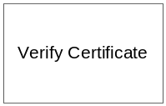

The system then allow the system admin to verify the softcopy of the generate certificates associated with a specific project and team members. The format content will be:

Project Name

Volunteer Name

Certificate Content

Generated Date

Print Certificate


The system then allows the system admin to print the generated certificates associated with a specific project and team members. The certificate content will be:

Project Name

Volunteer Name

Certificate Content

Generated Date

(Note: Informing for the certificate collection will be outside of the system)

System Control Panel
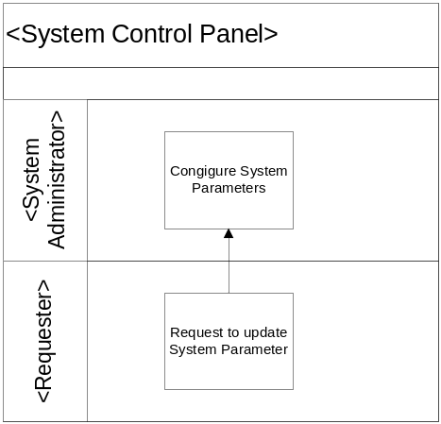

Configure System Parameters
- Requestor can request to update System Parameter.
- System Administrator shall configure System Parameter.

OPERATIONAL and Quality REQUIREMENTS

Operating Environment
The system shall operate in Internet and Intranet environment.
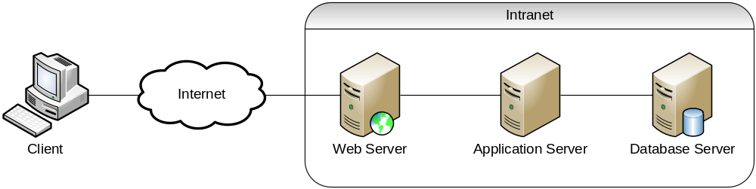

Development Constraints
The software shall be designed using the Rational Unified Process, and shall be coded using the Java programming language.

Performance
The system shall maintain an average of 3 seconds to response to every request from Intranet user or Internet user.

Reliability
The combined hardware and software system shall have 99% reliability. In particular during a 24 hour running period the system should not be unavailable for a period longer than 2 hours in total.

Availability
The system shall be available 24 hours a day, 7 days a week with 99% availability per year.

Capacity and Expandability
The design of the system shall be flexible in order to allow modifiability of the system.

Security
The system should require all users to enter a valid password to logon to the system. Each user will be granted access only to functions that are compatible with their responsibilities.

Future Growth
The VMS should be designed such that only minimal changes are required to modify it to meet the requirements of the volunteer management system.

